１ HarukaとMs.Smith（スミス先生）の会話文を読んで、あとの問いに答えなさい。
Ms. Smith : Look at this picture.
Haruka : Who is this girl?
Ms. Smith : This is me. I was four years old then.
Haruka : You were very cute! Who is this boy?
Ms. Smith : This is my brother. He was seven
years old then. This is my father and
mother.
Haruka : Nice picture! Where were you? There
are three cows in the picture.
Ms. Smith: We were in our farm. We lived in Idaho, and we had a lot of cows. Now, my parents still live there, but they don’t have them.

注）farm農場 parents両親
Idahoアイダホ州(アメリカ) stillまだ、今でも

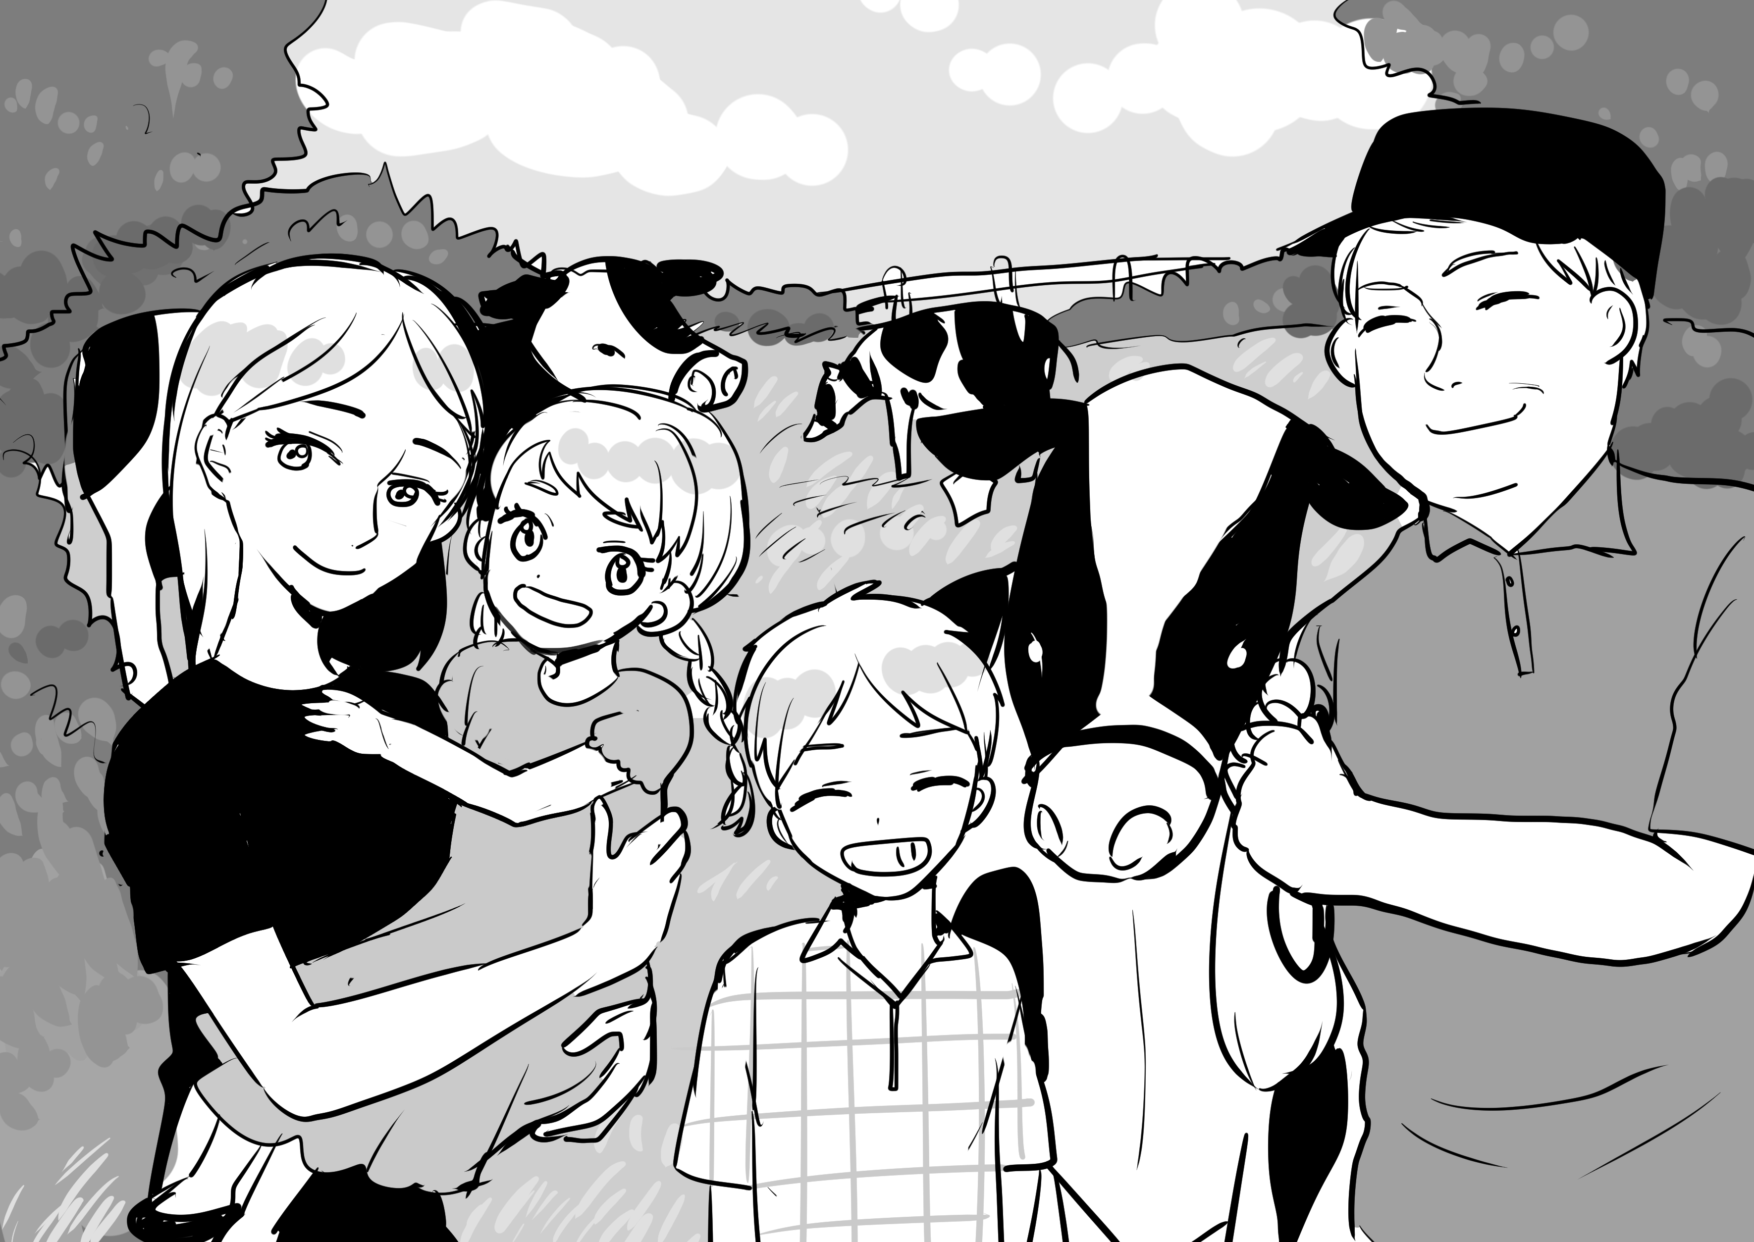

（１）本文の内容を表している下の文の（ ① ）～（ ③ ）に当てはまる日本語や
数字を書きなさい。(各５点)
スミス先生が小さい頃の写真をハルカに見せてくれた。アイダホ州に住んでいたスミス先生は、写真を撮った当時（ ① ）才、お兄さんは（ ② ）才だった。スミス先生の家族は（ ③ ）をたくさん飼っていた。今も両親はアイダホ州に住んでいるが（ ③ ）は飼っていない。

① ② ③

（２）次の質問に３語以上の英語で答えなさい。（各１０点）
Was Ms.Smith cute?

Where were Ms. Smith and her family in the picture?

２ 次の英文に（ ）の言葉を加えて、全文を書きかえなさい。(各５点)
（１）Your sister is a high school student. (last year)

昔の思い出＜be動詞 過去形＞

年 組 番 氏名

点
（２）They are very tired. (yesterday)

３ 次の文の[ ]内の語句を正しい順序に並べかえなさい。(５点)
I [ in, library, was, the ] at that time.

４ 次の対話文を読んで、あとの問いに答えなさい。
Mike: Where ( ① ) you after school yesterday?
Saki : I ( ② ) in the teachers’ room. I was talking with Mr. Saito about his junior high school days.
Mike: Sounds interesting!* Please tell me about it.
Saki : Okay. He ( ③ ) in the basketball club, and he was the captain* of the club. He liked English and P.E. but he didn’t like math.
Mike: Tell me more*.
Saki : Mr. Saito and Ms. Yoshida ( ④ ) classmates in their junior high school days!
Mike: Really? That’s surprising*!
Saki : Yes. I was surprised*, too.
Mike: Let’s talk with Ms. Yoshida today!
Saki : Sure!

注）Sounds interesting! 面白そう！
captainキャプテン moreもっと
surprising驚かされるsurprised 驚く

（１）①～④に適切なbe動詞を入れなさい。(各５点)
①（ ）②（ ）③（ ）④（ ）

（２） That’s surprising!の具体的な内容を日本語で書きなさい。（１０点）

５．次の[質問]に対して＜条件＞に従って２文以上の英文で書きなさい。(各１０点)
[質問] Where were you at eight last night?
＜条件＞ ①１文目はbe動詞を使って、[質問]に対する答えを書きなさい。
②２文目以降は、その時の自分の状態または感情を、be動詞を使って書きなさい。
①

②

