40 今日の試合は？ ＜現在完了進行形＞
点

１ トム（Tom）とケン（Ken）の電話での会話文を読んで、あとの問いに答えなさい。

Tom and Ken are in the same soccer club. Their *coach is Mr. Takeda. They have a practice game this afternoon. Now it is 11:30 in the morning.


Tom : Hello, this is Tom. Can I speak to Ken?
Ken : Speaking. Hi, Tom. What happened?
Tom : Well, I was *absent yesterday, so I don’t know enough about
today’s practice game. Please tell me about it.
Ken : I see. The game will start from 15:00. You know, it’s been
raining since last night. The practice game will be *canceled if it
rains a lot.
Tom : How do we know that?
Ken : Mr. Takeda will send an e-mail *by noon. He has been working as a volunteer since this
morning. So we have to wait for about thirty minutes.
Tom : I see, thanks. I hope it will stop raining.

注） coach…コーチ absent…欠席の cancel…取り消す by … ～までに

（１）トムがケンに電話をした理由を日本語で書きなさい。（１０点）

（２）次のア～エの英文で本文に対して、最も適切なものをア～エの中から１つ選び、
記号で書きなさい。（１０点）
ア Ken was absent from his soccer club yesterday.

イ Tom and Ken had a practice game this morning.
ウ If it rains a lot, the practice game will be canceled.
エ Mr. Takeda has been working as a teacher since this morning.

（３）本文に合うように、次の質問に指定された語数の英語で書きなさい。
①Has it been raining since last night? [３語で] （１０点）

②What has Mr. Takeda been doing since this morning? [５語以上で]（１０点）

年 組 番 氏名
２ ユウジ(Yuji)とミサキ(Misaki)の２人のスケジュールを見て、それぞれの今の様子を表す現在完了進行形の英文を解答欄の単語に続けてそれぞれ１文で書きなさい。（各１０点）
現在の時刻 | 人物 | 時間 | やっていること
15：00 | ユウジ | 13:00~17:00 | 兄の手伝い
15：00 | ミサキ | 10:00~16:00 | ピアノの練習
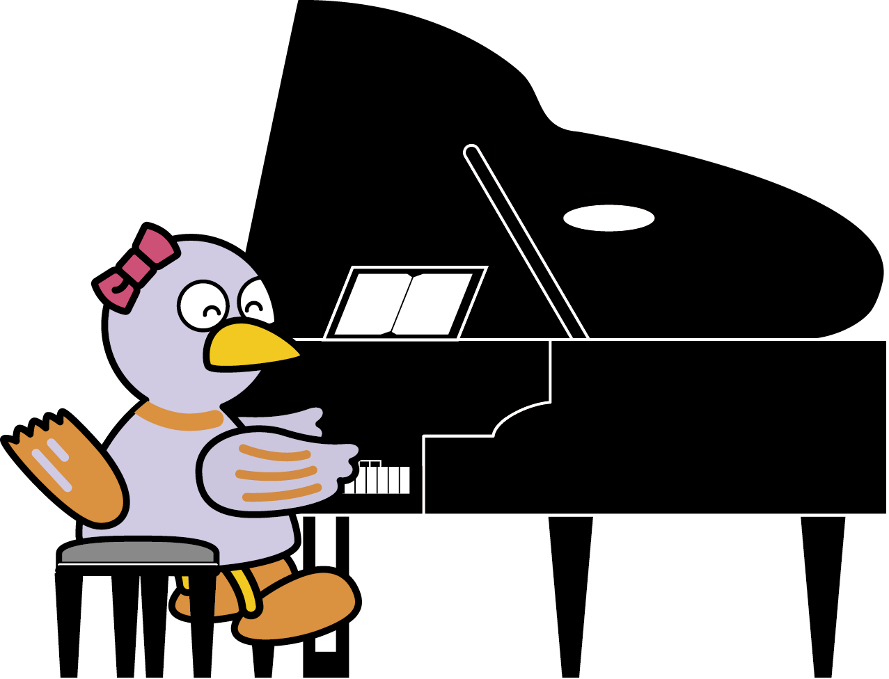

Yuji
Misaki
３ ほぼ同じ意味の英文になるように（ ）内の語を正しく並びかえ書きなさい。（各１０点）
（１） My father was sleeping two hours ago. He is still sleeping now.
( father / for / has / sleeping / hours / my / been / two / .)

（２） It snowed yesterday. It is still snowing now.
( been / yesterday / it / snowing / has / since / .)

４ 次のア～オの文で、英文として正しいものを２つ選び、それぞれ記号で
書きなさい。（各５点）
ア Ms. Sato have been knowing my father for fourteen years.
イ Ami has been reading the book since she came home from school.
ウ When have you been watching the movie?

エ Daisuke has been not studying math since ten o’clock.
オ Kei and I have been playing baseball for three hours.

５ 次の日本語を、現在完了進行形を用いた英文に直して書きなさい。（１０点）

・あなたのお姉さんはどのくらいの間料理をしていますか。

